Entity-Relationship Diagram for Bob’s Home Repair

Lane Dorscher
1/31/2026
CIS309-T302 Data and Information Management (2263-1)
Jack Li

Introduction
Bob’s Home Repairs is a small business that provides residential repair services. Currently, Bob manages customers, bids, repairs, materials, and payments manually using memory and paper records. This approach limits efficiency, increases the chance of error, and prevents the business from scaling.
This report proposes a relational database design to computerize the most burdensome business processes, including customer management, project tracking, bidding, repair execution, material usage, supplier relationships, and payment tracking. The proposed design follows relational database best practices and is structured to support future growth while remaining aligned with Bob’s current business rules.

Identified Entities and Attributes
CUSTOMER
Stores customer contact and billing information.
- CUSTOMER_ID (PK) – INT
- CUSTOMER_F_NAME – VARCHAR(30)
- CUSTOMER_M_NAME – VARCHAR(30)
- CUSTOMER_L_NAME – VARCHAR(30)
- CUSTOMER_STREET_ADDRESS – VARCHAR(150)
- CUSTOMER_CITY – VARCHAR(50)
- CUSTOMER_STATE – VARCHAR(30)
- CUSTOMER_ZIP_CODE – VARCHAR(14)
- CUSTOMER_PHONE – VARCHAR(12)
PROJECT
Represents a specific repair job or engagement for a customer.
- PROJECT_ID (PK) – INT
- CUSTOMER_ID (FK) – INT
- PROJECT_STREET_ADDRESS – VARCHAR(150)
- PROJECT_CITY – VARCHAR(50)
- PROJECT_STATE – VARCHAR(30)
- PROJECT_ZIP_CODE – VARCHAR(14)
- PROJECT_START_DATE – DATETIME
- PROJECT_END_DATE – DATETIME
- PROJECT_STATUS – VARCHAR(15)
BID
Represents a cost estimate provided for a project.
- BID_ID (PK) – INT
- PROJECT_ID (FK) – INT
- BID_DATE – DATETIME
- BID_ESTIMATED_HOURS – INT
- BID_LABOR_RATE – FLOAT
- BID_ESTIMATED_MATERIAL_COST – FLOAT
- BID_ESTIMATED_COST – FLOAT
- BID_STATUS – VARCHAR(15)
REPAIR
Represents individual repair tasks performed under an accepted bid.
- REPAIR_ID (PK) – INT
- BID_ID (FK) – INT
- REPAIR_DESCRIPTION – VARCHAR(255)
- REPAIR_HOURS_WORKED – INT
- REPAIR_LABOR_COST – FLOAT
MATERIAL
Represents catalog-level materials purchased from suppliers.
- MATERIAL_ID (PK) – INT
- SUPPLIER_ID (FK) – INT
- MATERIAL_NAME – VARCHAR(100)
- MATERIAL_DESCRIPTION – VARCHAR(255)
- UNIT_TYPE – VARCHAR(25)
- UNIT_COST – FLOAT
REPAIR_MATERIAL
Junction table that records which materials are used in which repairs.
- MATERIAL_ID (PK, FK) – INT
- REPAIR_ID (PK, FK) – INT
- QUANTITY_USED – INT
- EXTENDED_COST – FLOAT

SUPPLIER
Represents vendors from whom Bob purchases materials.
- SUPPLIER_ID (PK) – INT
- SUPPLIER_NAME – VARCHAR(100)
- SUPPLIER_CONTACT_NAME – VARCHAR(100)
- SUPPLIER_CONTACT_PHONE – VARCHAR(12)
- SUPPLIER_CREDIT_TERM_DAYS – INT
SUPPLIER_PAYMENT
Tracks payments made by Bob to suppliers.
- SUPPLIER_PAYMENT_ID (PK) – INT
- SUPPLIER_ID (FK) – INT
- PAYMENT_DATE – DATE
- PAYMENT_AMOUNT – FLOAT
- PAYMENT_METHOD – VARCHAR(20)
CUSTOMER_PAYMENT
Tracks payments made by customers after project completion.
- CUSTOMER_PAYMENT_ID (PK) – INT
- CUSTOMER_ID (FK) – INT
- PROJECT_ID (FK) – INT
- PAYMENT_DATE – DATE
- PAYMENT_AMOUNT – FLOAT
- PAYMENT_METHOD – VARCHAR(20)

Proposed Relationships
- A Customer can have many Projects.
- A Project belongs to one and only one Customer.
- A Project can have many Bids.
- A Bid belongs to one and only one Project.
- A Bid can include many Repairs.
- A Repair belongs to one and only one Bid.
- A Repair can have many Repair_Material records.
- A Repair_Material record belongs to one and only one Repair.
- A Material can appear in many Repair_Material records.
- A Repair_Material record references one and only one Material.
- A Supplier can provide many Materials.
- A Material is provided by one and only one Supplier.
- A Supplier can receive many Supplier Payments.
- A Supplier Payment belongs to one and only one Supplier.
- A Customer can make many Customer Payments.
- A Customer Payment belongs to one and only one Customer.
- A Project can have many Customer Payments.
- A Customer Payment may be applied to one Project.

Entity-Relationship-Diagram

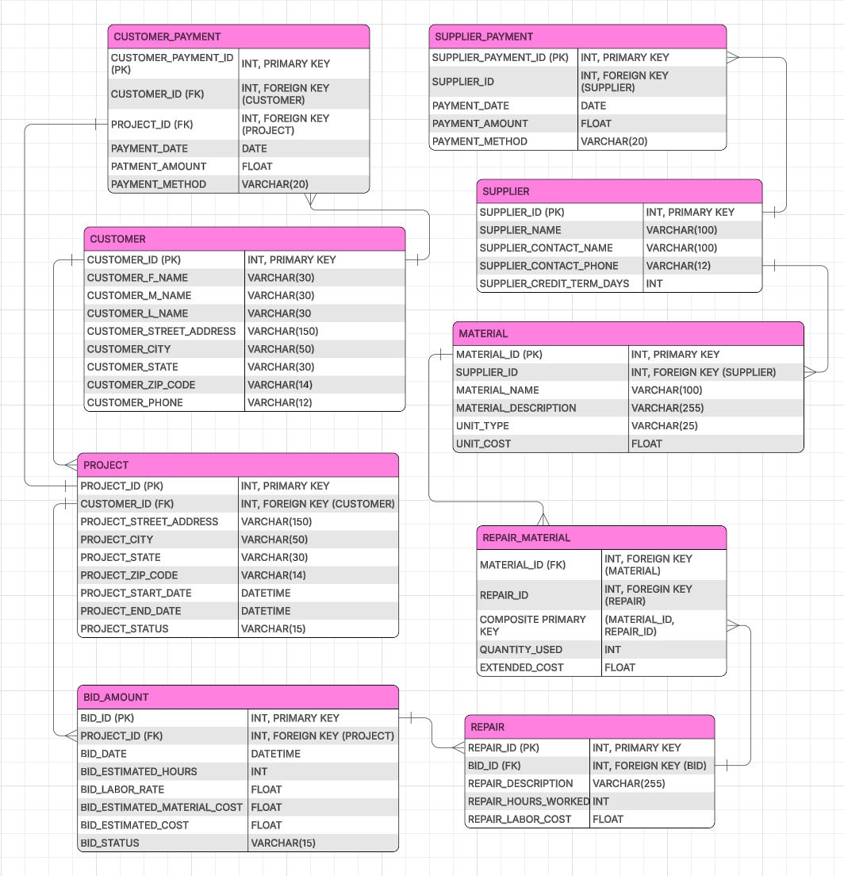

Design’s Intentions
The idea behind this design dictates that data redundancy will be reduced and the material definitions will be separated from their usage within a repair. This will also track whether a customer has multiple ongoing projects and whether the business has placed a bid on them. Multiple bids are allowed to be placed in effort to counter or keep track of outstanding bids on projects. Finally, this allows for flexible payment tracking ensuring that each project or repair has great references to which project has received payments. Utilizing this structure will provide a solid foundation for growth and maintain accurate reporting with the use of queries.

Conclusion
The proposed database design provides Bob’s Home Repairs with a scalable, organized, and efficient way to manage customers, projects, bids, repairs, materials, suppliers, and payments. By computerizing these core processes, Bob can reduce administrative overhead and focus more time on delivering quality repair services.

